Parth Babbar

network

Introduction:
Banking networks are interconnected systems and technology that allow financial organizations to provide a variety of services in an efficient and secure manner. These networks enable electronic financial transfers, payment processing, interbank communication, and ATM services, resulting in a complex web in the US banking industry. They are critical in linking institutions, enabling smooth financial transactions, and meeting regulatory criteria for interoperability, security, and operational efficiency.
Types:
- Automated Clearing House (ACH) Network: The Federal Reserve and the Clearing House oversee the ACH Network, which processes massive amounts of credit and debit transactions in batches. It quickly processes payroll, direct deposits, tax refunds, and consumer bills throughout the United States.
- Wire Transfer Networks: Wire transfers are real-time electronic payments used for high-value transactions. In the United States, the principal systems are Fedwire and the Clearing House Interbank Payments System (CHIPS). Fedwire, managed by the Federal Reserve, offers real-time gross settlement (RTGS) for big payments.
- SWIFT: The Society for Worldwide Interbank Financial Telecommunication (SWIFT) enables international payments using a secure messaging system for financial transactions. This network is critical to facilitating communication and transactions between banks throughout the world.
- Real-Time Payments (RTP) Network: The Clearing House's RTP network and Zelle enable rapid payments between banks and clients. The Clearing House's RTP network allows for real-time transaction clearing and settlement, which improves the speed and efficiency of financial transfers.
- Card Payment Networks: Networks that support transactions using credit, debit, and prepaid cards include Visa, MasterCard, American Express, and Discover. These networks authorize, clear, and settle card transactions, providing critical services for worldwide financial transactions.
Providers:
- Federal Reserve: Fedwire Funds Service, ACH Network, and National Settlement Service.
- The Clearing House: ACH, RTP, and CHIPS (Clearing House Interbank Payments System).
- SWIFT: A global financial communications network that facilitates international payments.
- Visa and MasterCard: Process card transactions, prevent fraud, and resolve disputes.
- Zelle: Real-time person-to-person payments.
Importance:
- Efficiency: Banking networks speed financial transactions, saving time and money over traditional banking processes.
- Security: Advanced encryption and fraud detection technology guarantee that transactions are safe.
- Accessibility: ATMs, internet banking, and mobile banking are available 24 hours a day, seven days a week.
- Collaboration: Different banks and financial organizations may interact and trade in a smooth manner.
Benefits:
- Improved Customer Experience: Customers benefit from increased convenience and speed when executing banking transactions, allowing them to do so at any time and from any location, dramatically lowering wait times.
- Cost Reduction: Automated procedures in banking improve operational efficiency by eliminating manual involvement and expenses. Electronic transactions reduce mistakes, resulting in cost savings for error correction.
- Enhanced Security: Advanced algorithms and real-time monitoring help detect and prevent fraudulent actions. Encryption and secure protocols provide strong data security, protecting sensitive consumer information.
- Broader Reach: Mobile banking and ATMs increase financial inclusion in rural places, whilst global networks such as SWIFT enable cross-border transactions, hence helping international trade.
- Innovation and Growth: Networks are driving the creation of new financial services such as real-time payments and mobile wallets. Collaborations with fintech businesses and other stakeholders promote development and innovation in the banking industry.
Challenges:
- Cybersecurity Threats: According to an Accenture analysis, the banking sector faces 300 times more cyberattacks than other businesses.
- Compliance and Regulatory Issues: Banks spend over $270 billion every year on compliance expenditures.
- Compatibility Issues: According to 70% of banking executives, a lack of compatibility across systems is a key impediment to digital transformation.
- Technical Failures: According to a Deloitte report, 25% of financial institutions face severe IT disruptions at least once each year.
- Customer Privacy Concerns: 83% of consumers are worried about how banks utilize their personal information.
Solutions:
- Cybersecurity: Banks improve security by implementing modern protocols like end-to-end encryption and biometric authentication. Continuous monitoring systems identify and respond to cyber threats in real time. Collaborations with cybersecurity organizations use professional knowledge and technology to improve defences
- Regulatory Compliance: Banks use automated systems for regulatory compliance to react to changing requirements and cut manual expenditures. Participation in regulatory sandboxes enables the testing of innovative goods in controlled situations. Employees get regular training to ensure they are aware of compliance standards and best practices.
- Interoperability: Banks use open banking APIs to seamlessly integrate with third-party suppliers. Collaboration with industry groups leads to the development of common interoperability standards. Blockchain technology exploration improves transaction transparency and interoperability.
- Technical Resilience: Banks deploy cloud computing to increase scalability and resilience, install redundant systems to ensure continuity during failures, and undertake frequent vulnerability testing.
- Customer Privacy: Banks use data minimization methods to acquire and maintain just the information they need about their customers. They guarantee that data usage rules are transparent and that customers have express consent for data processing. Advanced encryption techniques safeguard consumer data against illegal access.
Future Outlook:
- Blockchain and Distributed Ledger Technology (DLT): Blockchain improves security, transparency, and transaction efficiency, making it increasingly popular for cross-border payments, trade finance, and identity verification. It aims to expedite operations and increase confidence in digital transactions worldwide.
- Artificial Intelligence (AI) and Machine Learning (ML): AI and ML improve fraud detection, customize consumer experiences, and do predictive analytics. Their widespread use in risk management, chatbot customer service, and credit scoring improves operational efficiency and decision-making.
- 5G Technology: Banking technology improvements to provide speedier transactions, enhanced mobile banking, and IoT integration. 5G network growth enables next-generation financial apps.
- Quantum Computing: Quantum computing has promise for tackling complicated optimization issues, improving encryption, and speeding up data processing in the financial industry. Banks are currently investigating and testing quantum computing applications to better investigate its potential benefits.
Statistics:
- In 2022, the ACH Network handled approximately 30 billion payments valued at $76.7 trillion, up 3% and 5.6% from 2021.
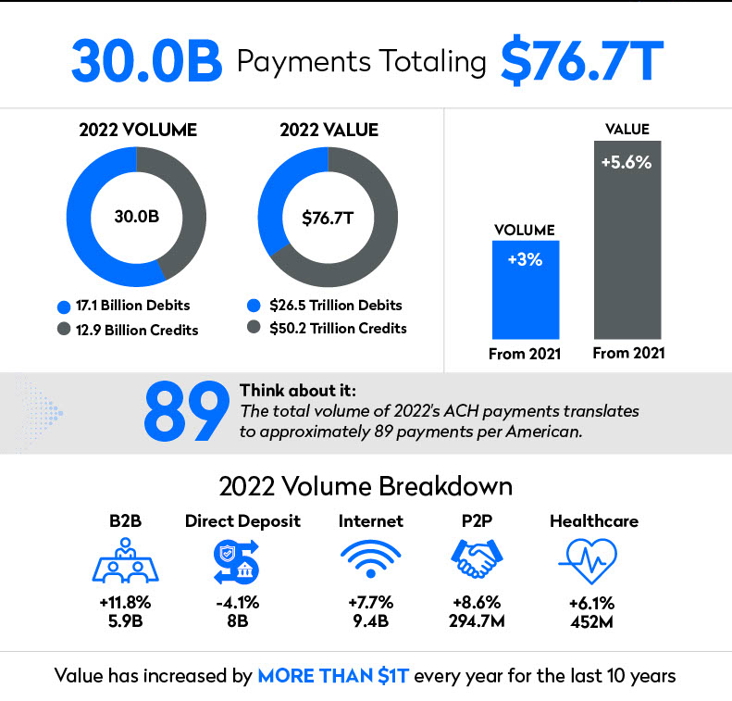
- In 2023, the Fedwire Funds Service executed around 184 million transactions valued at more than $835 trillion.
- In 2023, there were more than 100 billion card payment transactions in the United States, totalling more over $8 trillion.
- There are roughly 451,500 ATMs in the United States, with over 5.1 billion transactions each year.
Conclusion:
The networks in US banking are critical for ensuring efficient and safe financial transactions. Despite the problems of cybersecurity and regulatory compliance, there are several possibilities for innovation. Adopting sophisticated technology and strong security measures may boost network infrastructure and enhance customer service. Banking networks have a promising future, thanks to upcoming technologies like blockchain, AI, 5G, and quantum computing, which are poised to transform the sector.

